

**UNIVERSIADAD TECNOLÓGICA DE**

**SAN LUIS RIO COLORADO**

**HIERARCHY OF NEEDS**

**MTRA. YESENIA CORAL FLORES FLORES**

**AUTOR: VICTOR MANUEL GALVAN COVARRUBIAS**

San Luis Rio Colorado, Sonora Marzo, 2020

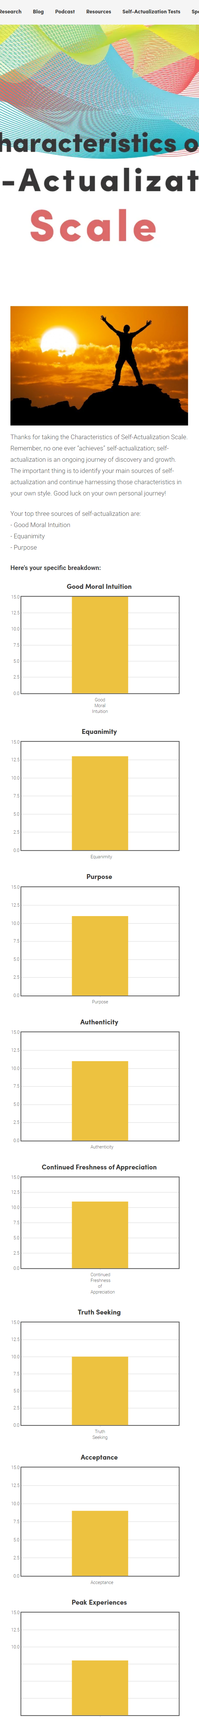



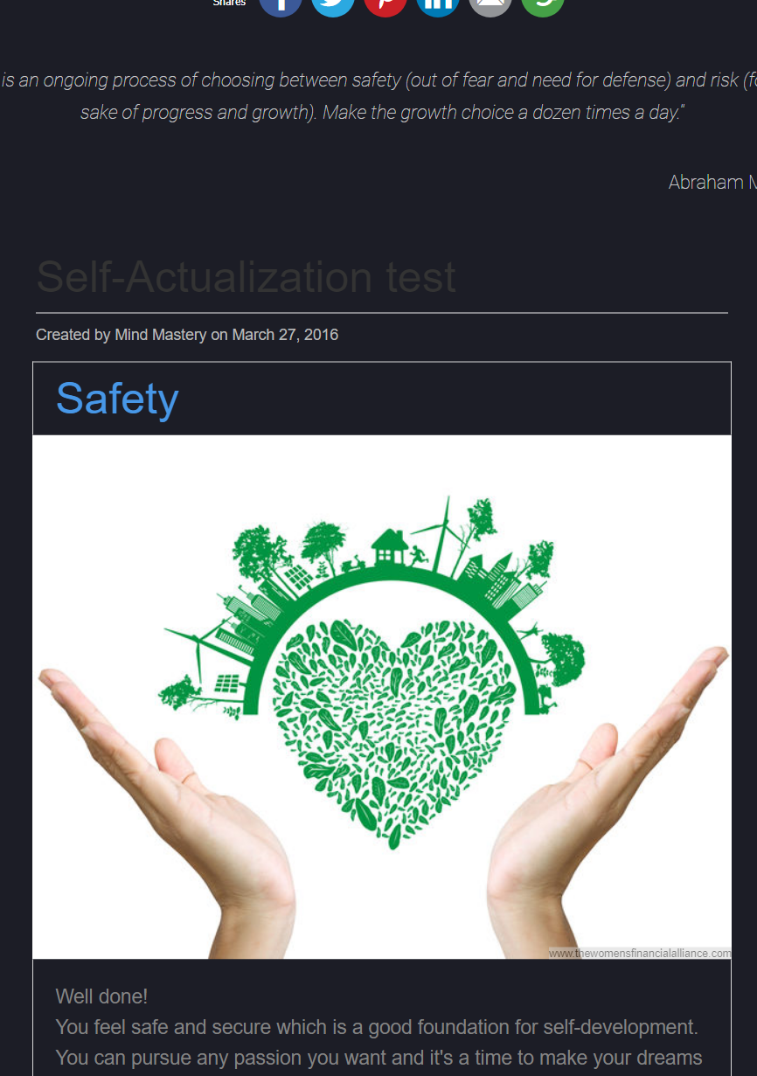

|  |  |  |
| --- | --- | --- |
| Hierarchy of needs | Ways you currently meet these needs | New practices to meet needs |
| **Physiological needs**  -basic human needs, food, water, and comfort. | 1. Eating the in the healthiest way.  2. Paying bill for the basic need | 1. Stop eating processed food.  2. Star working and pay myself. |
| **Safety needs**  -the desire for security, stability and safety. | 1. Having medical support from the government.  2. Respecting the law. | 1. Staying home.  2. Star respecting the police officials. |
| **Social needs**  -desire for affiliation including friendship and belonging | 1. Being social.  2. Going to university | 1. Be more respectful to other people.  2. Taking me out of my comfort zone. |
| **Esteem needs**  -desire for self-respect, and respect and recognition from others. | 1. Not talking to toxic people.  2. Making value of my opinion. | 1. Learn a new ability.  2. Stop making jokes. |
| **Self-actualization needs**  -desire for self-fulfillment | 1. Studying.  2. Forcing me to the limits. | 1. Read more books per year.  2. Play an instrument, |

**Maslow’s Hierarchy of needs worksheet**